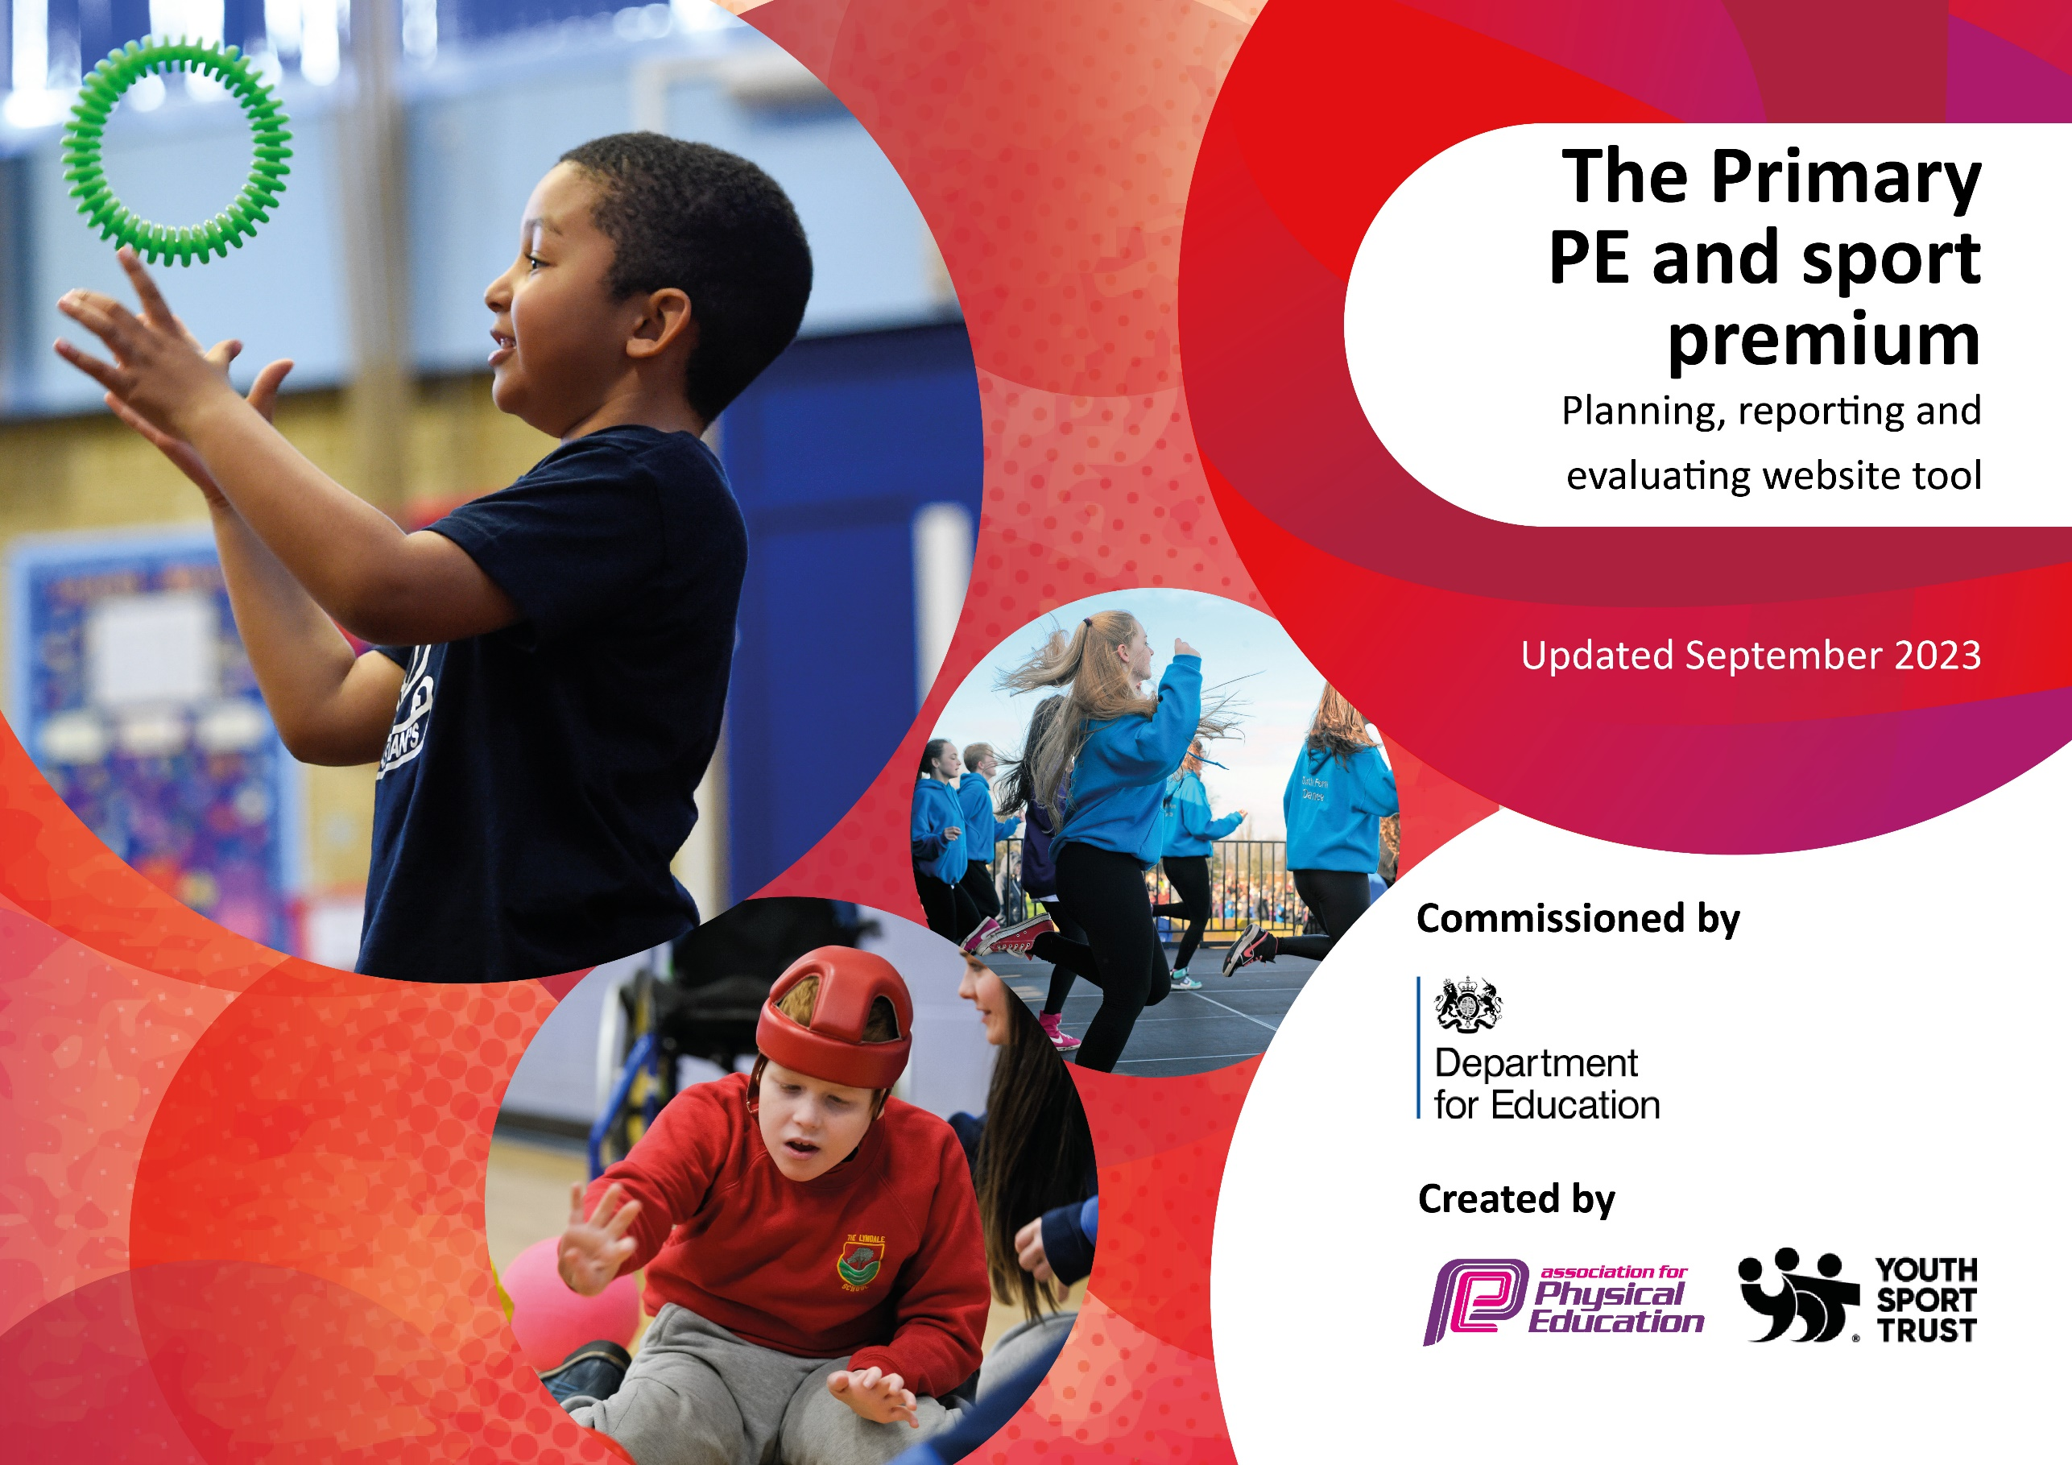

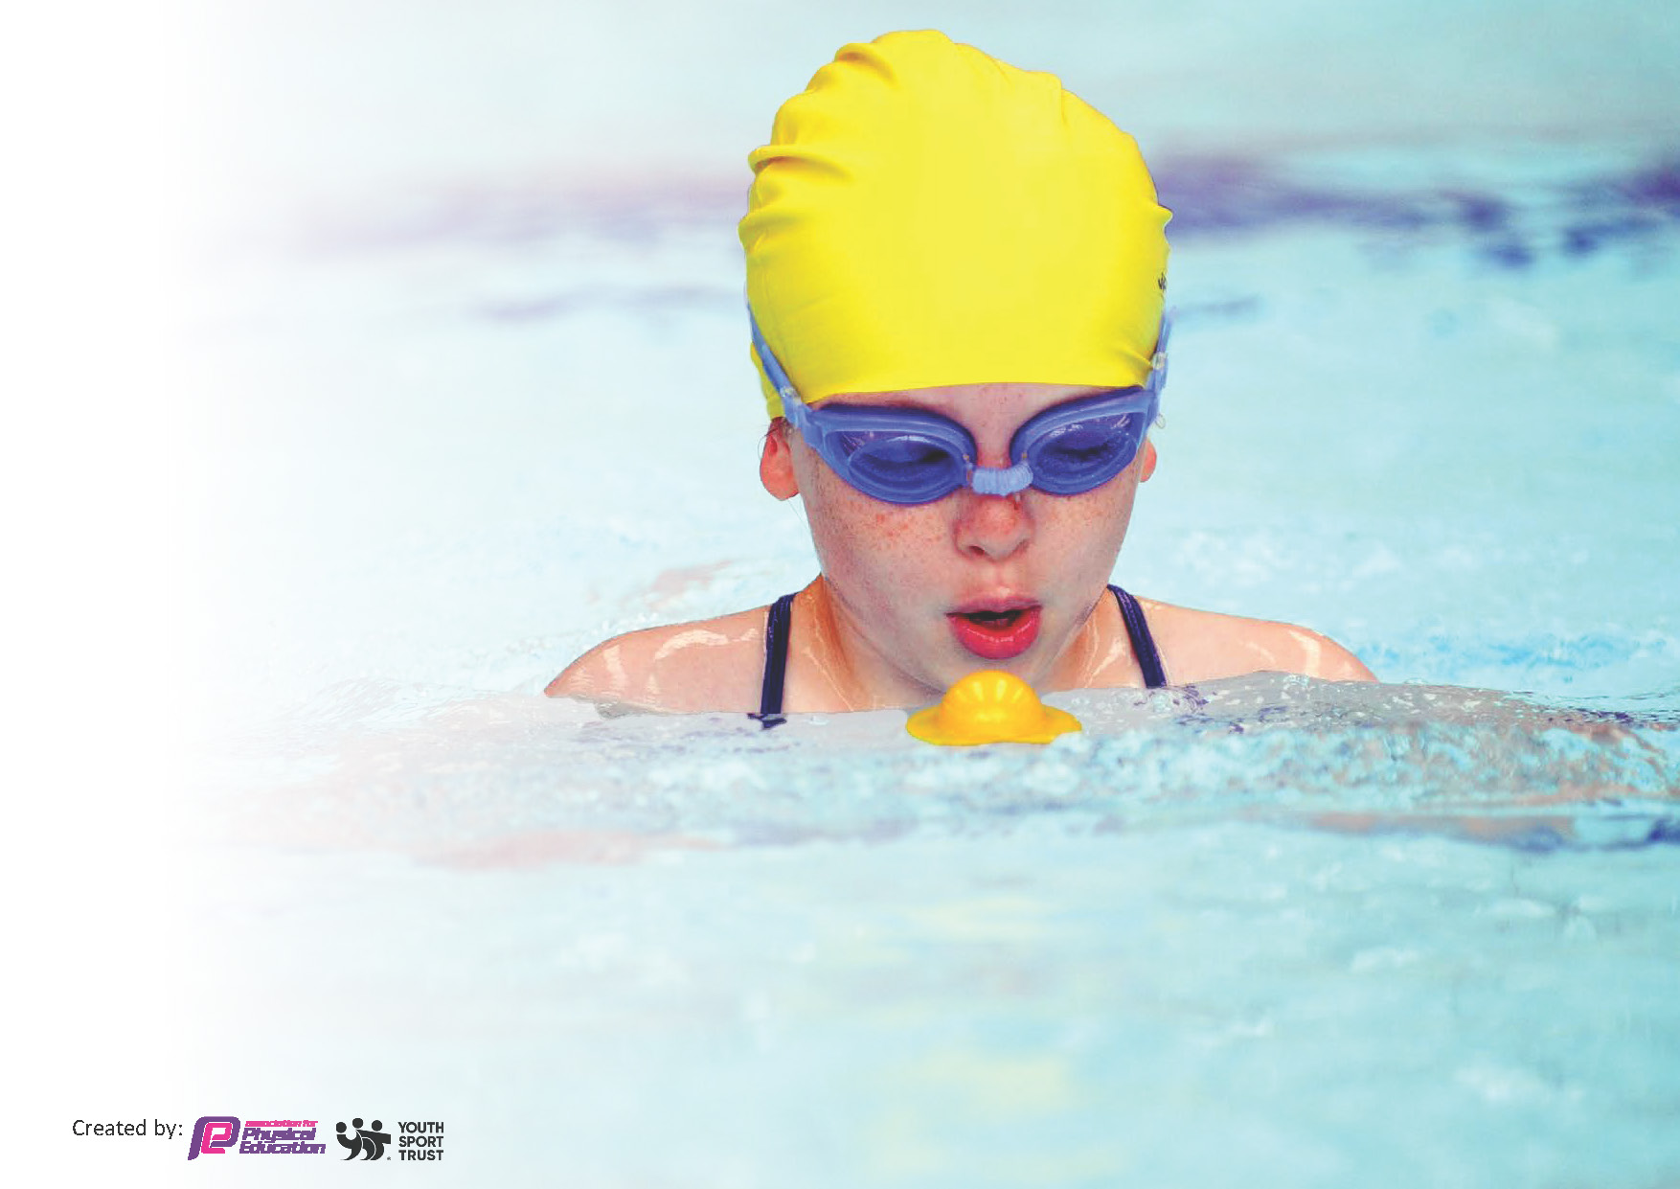
This template can be used for multiple purposes:
by:
- It enables schools to effectively plan their use of the Primary PE and sport premium
- It helps schools to meet the requirements (as set out in guidance) to publish information on their Primary PE and sport premium
- It will be an effective document to support Ofsted inspections enabling schools to evidence progress in Physical Education (PE) and evidence swimming attainment, which forms part of the PE National Curriculum. We would recommend schools consider
the Intent, Implementation and Impact of any spend, as examined within the Education Inspection Framework.

It is important that your grant is used effectively and based on school need.

Schools must use the funding to make additional and sustainable
improvements to the quality of the PE, School Sport and Physical Activity (PESSPA)
they offer. This means that you should use the Primary PE and sport premium to:

- Build capacity and capability within the school to ensure that improvements made now will benefit pupils joining the school in future years
- Develop or add to the PESSPA activities that your school already offers.

The Primary PE and sport premium should not be used to fund capital spend projects; the school’s core budget should fund these. Further detail on capital expenditure can be found in the updated Primary PE and sport premium guidance.

The Primary PE and sport premium guidance, outlines 5 key priorities that funding should be used towards. It is not

necessary that spending has to meet all the key priorities, you should select the priorities that you aim to use any funding towards.

Although completing this template is not a requirement for schools, schools are required to publish details of how they spend this funding. Schools must also outline what the impact this funding has had on pupils’ PE and sport participation and attainment and how any spending will be sustainable in the future. All funding must be spent by 31st July 2024.

The Department for Education has worked closely with the Association for Physical Education (afPE) and the Youth Sport Trust (YST) to develop this template and encourages schools to use it. This template is an effective way of meeting the reporting requirements of the Primary PE and sport premium.
Review of last year’s spend and key achievements (2022/2023)

We recommend you start by reflecting on the impact of current provision and reviewing your previous spend.

Activity/Action | Impact | Comments
Use specialist coaches and providers for team teaching & staff training to increase the knowledge and confidence of staff in delivering PE.  Premier Education started in our school in September 2023. | Increase in pupil participation across both Key Stages at lunch time and after school.  Children engagement in lessons and the delivery of CPD for all staff across the key stages and the academic year. | Increase in many pupils meeting CMO guidelines

Key priorities and Planning
This planning template will allow schools to accurately plan their spending.

Action – what are you planning to do | Who does this action impact? | Key indicator to meet | Impacts and how sustainability will be achieved? | Cost linked to the action
A large percentage of our Sports Premier on Premier Education to upskill staff and improve their competence and confidence through high quality CPD to help improve their teaching and the delivery of PE sessions.  Premier Education delivered three lunch clubs per week. This was to target the more in-active children across KS1 and 2 in the playground.  Premier Education deliver three after school sports clubs per week. This is aimed at children from Reception to Y6. Each club was changed per half term to include a more balanced and broader curriculum for the children. Also looking at gender equality and SEN needs.  Membership to the Christchurch School Sport Partnership 23-24  - Complete PE  - Youth Sport Trust Primary Membership  - Additional competitions outside of the School Games programme  - Comprehensive CPD programme  - PE Conference  - Dance project and festival  - Outdoor activity days  - Primary Leadership Academy  - Christchurch Sports Awards  - Support from partnership lead for team teaching and staff training.  - Bespoke additional training as necessary  We had two whole school projects this year which included:  Urban Strides Dance company and Circus skills. These were outside agencies who delivered a fun, broad and skill-based workshops for all children from Reception through to Year 6. | Teaching staff and lunch staff  Pupils – as they will take part.  Pupils – as they will take part.  Pupils – as they will take part.  Staff and pupils  Pupils – as they will take part. | Key indicator 1 - increasing all staff’s confidence, knowledge and skills in teaching PE and sport  Key indicator 4 - offer a broader and more equal experience of a range of sports and physical activities to all pupils  Key indicator 4 - offer a broader and more equal experience of a range of sports and physical activities to all pupils  Key indicator 1 - increasing all staff’s confidence, knowledge and skills in teaching PE and sport  Key indicator 2 - increasing engagement of all pupils in regular physical activity and sport  Key indicator 3 -  raising the profile of PE and sport across the school, to support whole school improvement  Key indicator 4 - offer a broader and more equal experience of a range of sports and physical activities to all pupils  Key indicator 5 - increase participation in competitive sport  Key indicator 4 - offer a broader and more equal experience of a range of sports and physical activities to all pupils | More pupils meeting their daily physical activity goal, more pupils encouraged to take part in PE and Sport Activities.  Increase in many pupils meeting CMO guidelines  Teachers confidence has increased due to their CPD session with Premier sports and the use of CompletePE.  Children enjoyment of PE is evident (as linked to pupil voice)  After school club offered opportunity for all children in every class to attend at least one club over the year.  There was an opportunity for 20 children to attend each club. 3x20 children per half term. 20 children x 6 clubs per term. (120 children)  Complete PE has given the staff confidence to teach a progressive and engaging curriculum. The use of the videos, brain breaks and clear lesson plans has increased participation across the Key stages.  Competitions have been successful this year. We participated in 15 events and the outdoor days at Moors Valley. These have given children a great opportunity to show perseverance, resilience and team building skills. | £12,030  Breakdown:  Lessons 3x£60 an afternoon  After school clubs £60.  Total £180  Autumn Term: £1620 and £2,280  Spring Term: £1,680 and £2,040  Summer Term: £2,040 and £2,370  £2500  Urban Strides Dance company (£565.21)  Circus skills (£650).

Key achievements 2023-2024
This template will be completed at the end of the academic year and will showcase the key achievements schools have made with their Primary PE and sport premium spending.

Activity/Action | Impact | Comments
We have spent a large percentage of our Sports Premier on Premier Education to upskill staff and improve their competence and confidence through high quality CPD to help improve their teaching and the delivery of PE sessions.  Premier Education also delivered three lunch clubs per week. This was to target the more inactive children across KS1 and 2 on the playground.  Premier Education deliver three after school sports clubs per week. These were aimed at children from Reception to Y6. Each club was changed per half term to achieve a more balanced and broader curriculum for the children.  As a school we contribute funding to sustain the Christchurch School Sport Partnership which provides the following opportunities:  - Complete PE  - Youth Sport Trust Primary Membership  - Additional competitions outside of the School Games programme  - Comprehensive CPD programme  - PE Conference  - Dance project and festival  - Outdoor activity days  - Primary Leadership Academy  - Christchurch Sports Awards  - Support from partnership lead for team teaching and staff training.  - Bespoke whole school development and support.  We had two whole school projects this year. We had Urban Strides Dance company (£565.21) and Circus skills £650). These were outside agencies who delivered a fun, broad and skill-based activities for children from Reception through to Year 6. | Increase in many pupils meeting CMO guidelines  Teachers confidence has increased due to their CPD session with Premier sports and the use of CompletePE.  Children enjoyment of PE is evident (as linked to pupil voice)  After school club offered opportunity for all children in every class to attend at least one club over the year.  There was an opportunity for 20 children to attend each club. 3x20 children per half term. 20 children x 6 clubs per term. (120 children)  Complete PE has given the staff confidence to teach a progressive and engaging curriculum. The use of the videos, brain breaks and clear lesson plans has increased participation across the Key stages. This is evident during learning walks and staff using Knowledge organisers to teach key skills during the lesson.  Competitions have been successful this year. We participated in 15 events and the outdoor days at Moors Valley. These have given children a great opportunity to show perseverance, resilience and team building skills.  Engagement for the whole school and the children experienced new skills. They also promoted resilience, perseverance and team work. The children also experienced presented these skills to the whole school and in front of their parents. | Lunch clubs and afterschool clubs have been a success.  Look at which year groups to target for Autumn 2024.  Continuously monitor physical activity levels and identify the most appropriate target groups to achieve maximum impact.  Use Christchurch PE Conference to review, evaluate and plan for the next academic year.  Continue into next year.  The circus skills workshops were a great success across the school.  Urban Strides was better for the KS2 children although all the KS1 enjoyed the experience!  Research into two new school initiatives for 2024-25.

Swimming Data
Meeting National Curriculum requirements for swimming and water safety.
Priority should always be given to ensuring that pupils can perform safe self-rescue even if they do not fully meet the first two requirements of the National Curriculum programme of study

Question | Stats: | Further context  Relative to local challenges
What percentage of your current Year 6 cohort can swim competently, confidently and proficiently over a distance of at least 25 metres? | 37% | Low percentage as we have children from low income families and the children don’t have access to their local pool except during the school swimming sessions.
What percentage of your current Year 6 cohort can use a range of strokes effectively [for example, front crawl, backstroke, and breaststroke]? | 37% | Low percentage as we have children from low income families and the children don’t have access to their local pool except during the school swimming sessions.

What percentage of your current Year 6 cohort are able to perform safe self-rescue in different water-based situations? | 45%
If your schools swimming data is below national expectation, you can choose to use the Primary PE and sport premium to provide additional top-up sessions for those pupils that did not meet National Curriculum  requirements after the completion of core lessons. Have you done this? | Yes/No | This is something we will look into for next year. We are also researching the cost and availability of a ‘pop up’ pool for the next academic year.
Have you provided CPD to improve the knowledge and confidence of staff to be able to teach swimming and water safety? | Yes/No | Staff observe the swimming instructors in the pool but they do not have the opportunity for any team teaching. This is due to outside agencies being used.

Signed off by:

Head Teacher: | Mrs Helen Frampton
Subject Leader or the individual responsible for the Primary PE and sport premium: | Emma Whitehead, PE Co-Ordinator and class teacher.
Governor: | (Name and Role)
Date: | 21.07.24.

